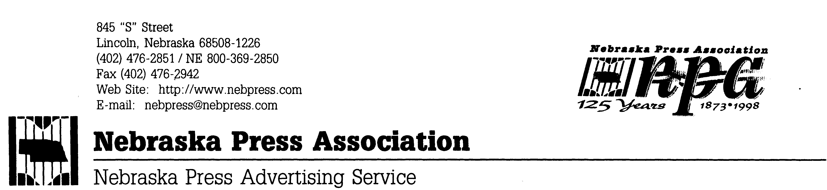

For Release: Saturday, April 18, 2015
Re: The Leadership Nebraska Award 2015

LINCOLN – When Don Harpst Jr. established The Leadership Nebraska Award in honor of his father, he must have had in mind a newspaper person precisely like this year’s recipient. Here is a woman who generously uses her journalism skills for community leadership.

Her leadership roles include these projects and memberships:

- Board member and chairwoman of the board of the Elkhorn Valley Historical Society in Norfolk.

- Board member and chairwoman of the Nebraska State Historical Society.

- She has also written a published book on the history of Norfolk and Elkhorn Valley, which served as a useful tool in classrooms and elsewhere for spurring greater appreciation and interest in history.

The 2015 recipient is SHERYL SCHMECKPEPER, Living page editor with the Norfolk Daily News. An excerpt from her nomination reads: “Through her passion and interest in history, Sheryl’s regular focus is on creating opportunities for younger Nebraskans to better appreciate historical elements and, as a result, be in a position to fill leadership roles in years and decades to come.”

The Harpst Leadership Nebraska Award was awarded Saturday, April 18, 2015, at the Nebraska Press Association’s 141st Annual Convention at the Holiday Inn-Downtown in Lincoln, NE. Russ Pankonin, Nebraska Press Association Foundation President, presented the award. A stipend comes with this award.

We again salute Sheryl Schmeckpeper.

—30—

