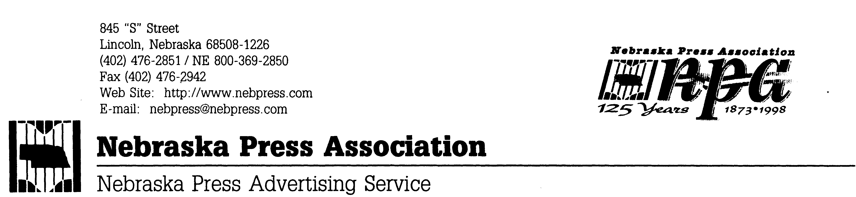
For Release: After 9:00 p.m., Friday, April 17, 2015.

LINCOLN—Awards announced Friday night at the Nebraska Press Association’s 141st Annual Convention at the Midtown Holiday Inn, in Grand Island, included those in competition for the Omaha World-Herald Community Service and Service to Agriculture awards.
Winners in the two categories were:

Community Service
Daily: Kearney Hub
Class A Weekly: Wauneta Breeze
Class B Weekly: no entries
Class C Weekly: Aurora News-Register
Class D Weekly: Blair Washington Co. Pilot Tribune
Service to Agriculture
Daily: Kearney Hub
Class A Weekly: Wauneta Breeze
Class B Weekly: no entries
Class C Weekly: Aurora News-Register
Class D Weekly: Blair Washington Co. Pilot Tribune

